**CIS 375 - Fall 2019 Term Project - BRAINS**



Use Case Summary Document

**Version No. 1.2.2**

**Project Document Revision History**

|  |  |  |  |
| --- | --- | --- | --- |
| **VersionNumber** | **Date** | **Revision Author** | **Description of Revision** |
| 1.0.2 | 10/21/2019 | Zakriya Ahmad | Edit the Use Case Summary |
| 1.1.0 | 10/27/2019 | Muaz Alhaidar | Revised the Use Case Summaries based off of feedback from client. |
| 1.1.1 | 10/28/2019 | Kevin Longworth | Revised the table of contents |
| 1.1.2 | 10/28/2019 | Mostafa El Majzoub | Further adjustment to the use case summaries. |
| 1.1.3 | 10/29/2019 | Zakariya Ahmed | Minor editing |
| 1.1.4 | 10/30/2019 | Muaz Alhaider | Deleting Database in |
| 1.1.5 | 10/30/2019 | Kevin Longworth | Changed what use case 2 covered |
| 1.1.6 | 11/11/2019 | Kevin Longworth | Changed use case 5 name in use case list, and removed audit company in actors list |
| 1.1.7 | 11/30/2019 | Muaz Alhaidar | Updated for removal of “schedule an update” feature |
| 1.2.0 | 12/13/2019 | Muaz Alhaidar | Adjusted the document for the removal of more features. All features thar were going to be made are now removed for descoping purposes. |
| 1.2.1 | 12/16/2019 | Muaz Alhaidar | Removed the departments submitting files functionality, STENERs removal, due date and marked late functionality for STENERs. |
| 1.2.2 | 12/17/2019 | Muaz Alhaidar | Further adjustments to documentation. New Use case diagram. |

|  |
| --- |
| **Table of Contents** |

1. Introduction 4

2. Project/Application Actors 4

3. Use Case List 4

4. Use Case Diagram(s) 5

5. Use Case Summary 6

6. Use Case Summary Review and Signoff 7

# Introduction

This document captures BUSINESS requirements at a high level by identifying ALL the use cases in a project/application.

This project will create a unified system for companies to track and ensure all of their departments are following required guidelines and regulations. Right now, companies are relying on trust of each department that they are following requirements, and keeping it in an organized fashion. This program will be a software that is easy to use, with effective methods to keep all of the data organized, with proof that each department is following the regulations, so there is no doubt that they are being followed.

When companies do not follow regulations, if they get caught, it can be timely and expensive, as they have to fix the problem before they can work on anything else, as well as be fined. Once this program is in place, it will save the headaches of going through each regulation manually, and remove the risk of getting a fine due to not following the rules.

# Project/Application Actors

An actor is someone or something (e.g. application system) outside the system or business that interacts with the application. List the actors involved in ANY use case. Actors should be a person, system, or time.

|  |  |
| --- | --- |
| Actor Name | Description |
| Departments | Employees of each departments answer questions on the STENERs |
| Oversight team | Manages the STENERs and Questions submitted by Departments with the ability to modify/add both. |

# Use Case List

List ALL use cases identified for the project/application.

1. Answer Submission and Completion
2. Login and Account Interaction
3. Question Maintenance
4. STENER Management
5. Users Management

# Use Case Diagram(s)

Show diagram(s) that - ALL actors and ALL use cases identified in sections 2 and 3 must be represented somewhere in the diagram(s). IF multiple use case diagrams are created because of groupings of business functionality assigned a number and name to each diagram for ease of reference.

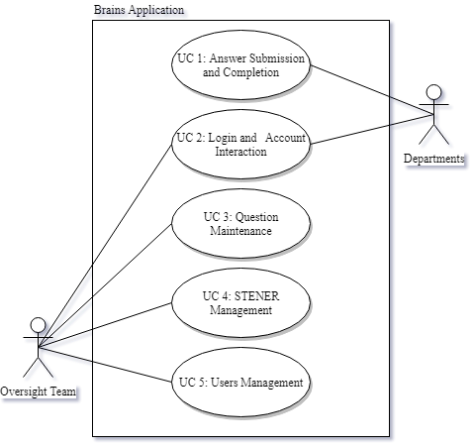

# Use Case Summary

For each use case include: Introduction of use case (one paragraph, will also be “introduction” to individual use case specification document), use case diagram number and name reference (if exists), list of main actors and list of secondary actors (these MUST match the lists in the individual use case specification document).

1. Answers Submission and Completion

This is the use case of answering questions and storing answers. Databases store the answers, receiving it from the Departments. The Departments answer the STENERS, which gets sent to the Database. If the STENER isn’t finished yet and is submitted, return with an error message saying “Need to complete STENER” This is Use Case 1, with the Departments as actors.

1. Login creation and Account Interaction

This is to check if a user has validation to login and answer the question. While Databases store accounts, with Departments having accounts. This is Use Case 2, with the Departments and Oversight Team as actors.

1. Question Maintenance

This use case is for adding, removing, or modification of questions done by the Oversight Team. These get sent to Departments for answering. This is Use Case 3, with the Oversight Team as the actors.

1. STENER management

The Oversight Team can update questions on, create, reject, approve entire STENERs. If a STENER is rejected, Oversight has the ability to create a violation log with a date, description, and rating. This is Use Case 5, with the Oversight Team as the actors.

1. Users Management

This is the creation and removal of users done by the Oversight Team. The Oversight Team can edit user to view or be able to answer STENER reports. The only reason to add/remove users is to view the STENERs they are assigned to. This is Use Case 6, with the Oversight Team as the actors.

# Use Case Summary Review and Signoff

|  |  |  |  |
| --- | --- | --- | --- |
| Review and Signoff of the Use Case Summary | | | |
| Name | Project Team Role | Signature | Date |
| Ahmed, Zakariya | Senior Tech Lead/SPMP manager | Z.A. | 12/17/2019 |
| Alhaidar, Muaz | Developer | M.A. | 12/17/2019 |
| Longworth, Kevin | Developer | K.L. | 12/17/2019 |
| Labut, Cameron | Developer | C.L. | 12/17/2019 |
| Majzoub,Mostafa El | Developer | M.M. | 12/17/2019 |